
VENTURE CREATION · GSLC ASSIGNMENT
Robust Design Factor Identification
Faunora: pet diet consultation & in-house catering
Name | Student ID (NIM) | Role
Siegfried Vesakha Setiawan | 2802405882 | CEO
Kayne Deron Kusnadi | 2802405150 | COO
Angelino Delvin | 2802526271 | CFO
Andi Siti Maryam Shaskirana | 2802462500 | CMO

BINUS University · October 2026

Contents
1. Executive Summary 3
2. Business Context 3
2.1 From Peybo to Faunora 3
2.2 How the service works 4
2.3 Why robustness matters for Faunora 4
3. Framework: Taguchi Robust Design 4
4. The Faunora P-Diagram 5
4.1 Ideal function 5
4.2 Signal factors (inputs from the customer) 5
5. Control Factors 5
6. Noise Factors 6
7. Responses and Quality Characteristics 7
8. Robust Design Experiment: Cold-Chain Packaging (L9) 7
8.1 Factors, levels and noise conditions 8
8.2 Results 8
8.3 Factor ranking 9
8.4 Optimal setting and decision 9
9. Process FMEA: Catering Risks 9
10. Robust Design Strategies 10
11. Desirability, Feasibility and Viability Check 11
12. Conclusion and Next Steps 11
Assumptions 11

1. Executive Summary
Faunora is a pet-care business built on two pillars: diet consultations with professional pet nutritionists, and catering from our own kitchen and online shop (homemade meals, snacks, toys and fashion, sold only by us; not a marketplace). This document identifies the design factors that decide whether Faunora delivers the same quality to every pet, every week, regardless of conditions we cannot control.
We apply Taguchi's Robust Design method. Using a P-Diagram we separate the customer's input (signal), the outputs we promise (response), the choices we control (11 control factors) and the sources of variation we cannot control (noise, in three types). We then test the most critical factor, the cold-chain packaging, with an L9 orthogonal-array experiment, and rank operational risks with a process FMEA.
Key findings
• Insulation type is the strongest control factor for delivery temperature (effect range 4.9 dB), followed by the number of gel packs (3.0 dB). Pouch type matters little (0.7 dB).
• Recommended setting: recycled-paper insulated box + 3 gel packs + vacuum-sealed pouch, with delivery routes capped at 3 hours. EPS foam scores about 1 dB better than paper but is hard to recycle, so paper is preferred.
• Highest operational risks (RPN): owner feeding habits at home (210), delivery temperature (200) and nutrient drift during cooking (150). Each has a designed countermeasure.
• All experimental and survey numbers in this document are assumption-based simulations for the assignment, clearly labelled, and must be replaced by real measurements in the pilot.

2. Business Context

2.1 From Peybo to Faunora
The first concept (Peybo) combined diet consultations, grooming booking, an Agoda-style pet-hotel marketplace and a multi-vendor shop. After consultation with our professor we narrowed the business to what makes it different: the diet. Grooming and hotel booking were dropped because competitors (SobatPaws, FIX, Petbacker) already serve them well.
Kept (core) | Dropped
Diet consultation with licensed vets and certified nutritionists (video call, later home visits) | Grooming booking
Catering: meals cooked to the diet plan in our own kitchen, delivered chilled | Pet-hotel marketplace and booking commission
In-house shop: our own snacks, toys and pet fashion | Multi-vendor marketplace and featured listings

2.2 How the service works
A pet owner books a consultation, the nutritionist writes a diet plan (calories, portions, allergens to avoid), and our kitchen cooks meals to that plan. Ingredients are bought directly from local farmers (vegetables from Lembang, free-range chicken from Bogor, fish from Muara Angke), cooked in small batches in our own kitchen, portioned per feeding, vacuum-sealed, chilled and delivered in a scheduled morning window.
  Figure 1. Direct sourcing from local farmers (AI-generated illustration). |   Figure 2. Homemade, small-batch cooking in our own kitchen (AI-generated illustration).

2.3 Why robustness matters for Faunora
Our promise is consistency: the right nutrition, every week, for each individual pet. Unlike a packaged-kibble brand, our product is fresh food delivered through Jakarta heat and traffic, made from farm ingredients that vary by season, and fed by owners with their own habits. If the service only works under ideal conditions, pets miss their goals and owners leave. Robust design lets us build quality in at the design stage instead of inspecting failures afterwards.

3. Framework: Taguchi Robust Design
Robust Design (Genichi Taguchi) aims to make a product or service perform on target with minimum variation, even when uncontrollable conditions change. Instead of removing the causes of variation (often expensive or impossible, e.g. Jakarta weather), we choose design settings that make the output insensitive to them. We followed six steps:
- Define the ideal function: what a perfect Faunora service delivers.
- Draw the P-Diagram: signal, response, control factors, noise factors and error states.
- Classify noise into outer (environmental), inner (deterioration) and unit-to-unit variation.
- Select quality characteristics and their signal-to-noise (S/N) type: nominal-the-best, smaller-the-better or larger-the-better.
- Run an orthogonal-array experiment on the most critical subsystem (cold-chain packaging) under deliberately applied noise.
- Choose the robust setting and plan a confirmation run; support it with a process FMEA for the remaining risks.

4. The Faunora P-Diagram
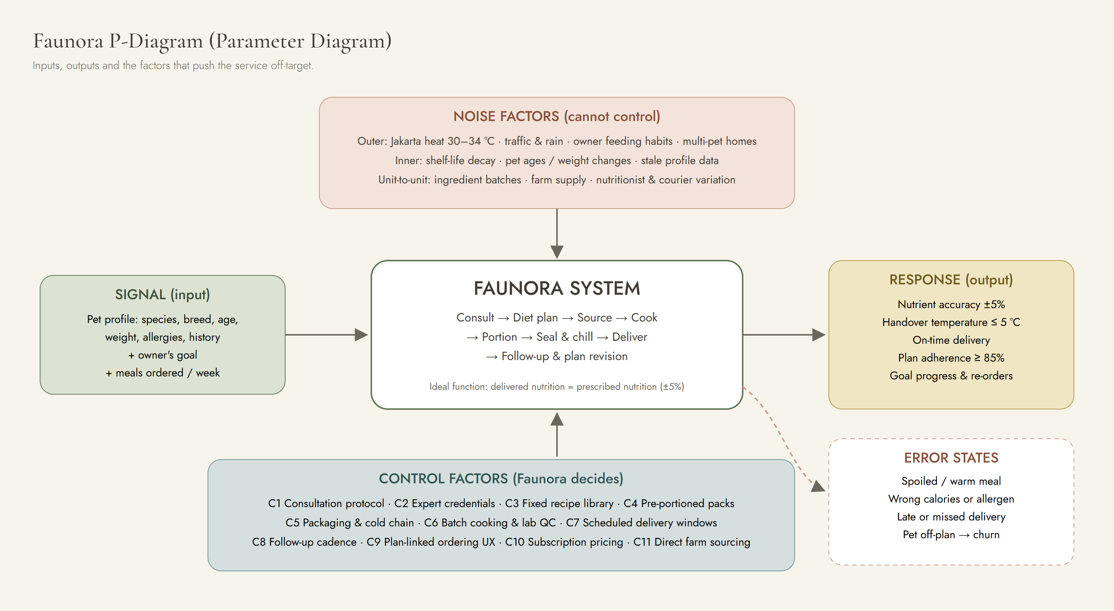
Figure 3. Faunora P-Diagram: signal, response, control and noise factors, and error states.

4.1 Ideal function
For every pet profile, the nutrition the pet actually eats equals the nutrition the nutritionist prescribed (±5%), delivered fresh (≤ 5 °C), on time, and fed as instructed, so the pet moves steadily towards its health goal.

4.2 Signal factors (inputs from the customer)
Signal | Description | Range Faunora must handle
Pet profile | Species, breed, age, weight, body condition score, allergies, medical history | Kittens to senior dogs; 2–40 kg
Owner's goal | Weight loss, allergy management, senior care, recovery, general health | Five concern categories
Order volume | Meals per week per pet | 7–28 portions
Delivery address | Location within Jabodetabek | 5–35 km from the kitchen

5. Control Factors
Control factors are design choices Faunora makes and can hold constant. The "robust setting" column shows the level we select and the reason.
# | Control factor | Levels considered | Robust setting & reason
C1 | Consultation protocol | Free-form · standard checklist + energy calculator | Standard checklist: reduces variation between nutritionists
C2 | Expert credentials | Any nutrition coach · licensed vet (drh.) / certified nutritionist | Licensed only: customer trust (75% looked for the title in testing)
C3 | Recipe formulation | Fully custom per pet · fixed library of 12 base recipes | Fixed library with portion adjustment: consistent, testable quality
C4 | Portioning | Bulk tub · pre-portioned per feeding, labelled with kcal and pet name | Pre-portioned: removes owner measuring error
C5 | Packaging & cold chain | Insulation × gel packs × pouch (see Section 8) | Paper insulated box + 3 gel packs + vacuum pouch
C6 | Cooking & QC | Cook to order · weekly small batches with lab test | Weekly batches: controls ingredient variation, enables testing
C7 | Delivery | Instant courier · scheduled morning windows, routes ≤ 3 h | Scheduled windows: predictable cold chain, lower cost
C8 | Follow-up cadence | None · check-ins at weeks 2, 6 and 12 | Scheduled check-ins: catches changes in the pet
C9 | Ordering UX | Free browsing · plan-linked "shop by need" and one-tap reorder | Plan-linked: fewer wrong purchases (finding from prototype test)
C10 | Pricing model | Pay per item · consultation + monthly meal subscription | Subscription: steady demand so the kitchen can plan batches
C11 | Ingredient sourcing | Wholesale market · direct from 2+ local farms per ingredient | Direct, multi-farm: fresher, traceable, resilient to one farm failing

6. Noise Factors
Noise factors cause variation but are impossible or too expensive to control. Taguchi groups them into three types:
Type | Noise factor | Effect on Faunora
Outer (environmental) | Jakarta heat and humidity (30–34 °C) | Food warms during delivery; faster spoilage
Outer | Traffic congestion, rain and flooding | Longer transit; late deliveries
Outer | Owner feeding habits (table scraps, skipped meals) | Pet off-plan even when food is correct
Outer | Multi-pet households | Wrong pet eats the wrong portion
Outer | Seasonal prices and supply (e.g. fish in monsoon) | Cost spikes; recipe substitutions
Inner (deterioration) | Shelf-life degradation of chilled meals | Nutrient loss, lower palatability
Inner | Pet ages, gains or loses weight, becomes ill | Original plan stops fitting
Inner | Pet profile in the app goes out of date | Portions based on old weight
Unit-to-unit | Batch-to-batch ingredient variation (fat content) | Calorie and nutrient deviation
Unit-to-unit | Farm-to-farm supply variability | Short supply on cooking day
Unit-to-unit | Different nutritionists and couriers | Inconsistent plans and handling

7. Responses and Quality Characteristics
Each response is measured and assigned a signal-to-noise (S/N) ratio type. A higher S/N always means better and more robust performance.
Response | Measure | S/N type | Target
Nutrient accuracy | Lab kcal and protein vs. recipe spec | Nominal-the-best: 10·log(ȳ²/s²) | ±5% of spec
Delivery temperature | Core temperature at handover | Smaller-the-better: −10·log(Σy²/n) | ≤ 5 °C
Delivery delay | Minutes after promised window | Smaller-the-better | 0 (max 30 min)
Plan adherence | % of portions fed as instructed (owner log) | Larger-the-better: −10·log(Σ(1/y²)/n) | ≥ 85%
Goal progress | % of pets on track at week 12 | Larger-the-better | ≥ 70%
Retention | Monthly subscription renewal | Larger-the-better | ≥ 75%

8. Robust Design Experiment: Cold-Chain Packaging (L9)
Delivery temperature is the response most exposed to noise (heat and traffic) and the one most likely to cause a serious error state (spoiled food). We therefore tested three packaging control factors at three levels each. A full factorial would need 3³ = 27 combinations; Taguchi's L9 orthogonal array gives a balanced view of each factor in only 9 runs.
Simulated data. The values below are assumption-based estimates created for this assignment to demonstrate the method. The real experiment is planned for the pilot using a probe thermometer and 36 test boxes.

8.1 Factors, levels and noise conditions
Factor | Level 1 | Level 2 | Level 3
A. Insulation | Thermal foil bag | EPS foam box | Recycled-paper insulated box
B. Gel ice packs | 1 gel pack | 2 gel packs | 3 gel packs
C. Pouch | Standard zip pouch | Vacuum-sealed pouch | Vacuum + portion tray

Each run was exposed to a noise array of four conditions combining transit time and ambient temperature: 2 h · 28 °C, 2 h · 34 °C, 5 h · 28 °C, 5 h · 34 °C. The response is core food temperature at handover (°C), smaller-the-better.

8.2 Results
Run | A | B | C | y: 2 h · 28 °C | y: 2 h · 34 °C | y: 5 h · 28 °C | y: 5 h · 34 °C | Mean °C | S/N dB
1 | Thermal foil bag | 1 gel pack | Standard zip pouch | 10.3 | 11.6 | 13.2 | 15.3 | 12.60 | -22.10
2 | Thermal foil bag | 2 gel packs | Vacuum-sealed pouch | 7.0 | 9.0 | 10.0 | 12.5 | 9.62 | -19.85
3 | Thermal foil bag | 3 gel packs | Vacuum + portion tray | 6.6 | 8.0 | 9.5 | 11.4 | 8.88 | -19.14
4 | EPS foam box | 1 gel pack | Vacuum-sealed pouch | 6.0 | 7.1 | 7.4 | 8.7 | 7.30 | -17.34
5 | EPS foam box | 2 gel packs | Vacuum + portion tray | 4.1 | 4.6 | 5.4 | 6.3 | 5.10 | -14.27
6 | EPS foam box | 3 gel packs | Standard zip pouch | 4.1 | 5.0 | 5.5 | 6.9 | 5.38 | -14.76
7 | Recycled-paper insulated box | 1 gel pack | Vacuum + portion tray | 6.5 | 7.2 | 8.2 | 9.5 | 7.85 | -17.99
8 | Recycled-paper insulated box | 2 gel packs | Standard zip pouch | 5.2 | 6.4 | 7.1 | 8.1 | 6.70 | -16.63
9 | Recycled-paper insulated box | 3 gel packs | Vacuum-sealed pouch | 3.9 | 4.8 | 5.2 | 6.8 | 5.17 | -14.45

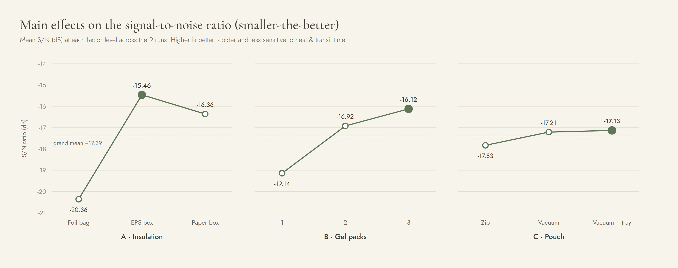
Figure 4. Main-effects plot. The filled point marks the best level of each factor.

8.3 Factor ranking
Factor | Level 1 | Level 2 | Level 3 | Range (Δ) | Rank
A. Insulation | -20.36 | -15.46 | -16.36 | 4.90 | 1
B. Gel packs | -19.14 | -16.92 | -16.12 | 3.02 | 2
C. Pouch | -17.83 | -17.21 | -17.13 | 0.70 | 3

8.4 Optimal setting and decision
The statistically best combination is A2 (EPS box) + B3 (3 gel packs) + C3 (vacuum + tray), with a predicted S/N of about −13.9 dB. Our recommended setting is A3 (recycled-paper box) + B3 + C2 (vacuum pouch), with a predicted S/N of about −14.9 dB:
- EPS foam is only ~1 dB better than paper, but it is bulky, hard to recycle and conflicts with our "fresh, natural, local" brand.
- The vacuum + tray pouch adds cost for only a 0.08 dB gain over the plain vacuum pouch.
- In every run the worst readings came from the 5 h · 34 °C noise condition. Rather than over-packing every box, we reduce exposure to this noise with control factor C7: routes capped at 3 hours. This is the robust design idea in practice: we change the design so the noise matters less.
Confirmation run (planned): 12 boxes at the recommended setting across the four noise conditions. The setting is accepted if every box arrives at ≤ 5 °C when transit is ≤ 3 hours.

9. Process FMEA: Catering Risks
To cover the rest of the catering process, from consultation to feeding at home, we scored each failure mode for Severity (S), Occurrence (O) and Detection (D) on a 1–10 scale. Risk Priority Number RPN = S × O × D. Items scoring 120 or more receive priority action.
Step | Failure mode | Effect | Noise / cause | S | O | D | RPN | Robust countermeasure
Consult | Two nutritionists give different plans for similar pets | Lower trust; inconsistent results | Nutritionist variability | 6 | 4 | 5 | 120 | Standard intake checklist, shared energy calculator, senior-vet review of first 10 plans
Source | A partner farm is short of a key ingredient | Recipe cannot be cooked on time | Weather, harvest size | 6 | 5 | 3 | 90 | Two or more farms per key ingredient; pre-approved seasonal substitutes
Inspect | Spoiled or contaminated produce is accepted | Pet illness, brand damage | Supplier handling | 10 | 2 | 4 | 80 | Receiving temperature check, supplier hygiene checklist, weekly lab sample
Cook | Calorie/protein content drifts from the recipe | Pet misses weight goal | Fat content varies per batch | 6 | 5 | 5 | 150 | Fixed recipe library, ingredients weighed, batch proximate analysis
Portion | Wrong portion or label goes to a pet | Allergen exposure, wrong kcal | Human error, multi-pet homes | 8 | 3 | 4 | 96 | Labels printed from the plan, barcode check at packing, colour code per pet
Seal & chill | Vacuum seal leaks | Shorter shelf life | Pouch defect | 7 | 3 | 3 | 63 | Seal inspection, blast-chill log to 4 °C
Deliver | Meal arrives above 5 °C | Spoilage risk, complaint | Heat, traffic, long routes | 8 | 5 | 5 | 200 | Packaging set by L9 experiment, routes capped at 3 h, temperature sticker
Feed at home | Owner over-feeds or mixes in other food | Pet off-plan, churn | Owner habits | 5 | 6 | 7 | 210 | Feeding calendar on box, WhatsApp reminders, check-ins at weeks 2, 6, 12

10. Robust Design Strategies
The table maps each important noise to the control-factor setting that makes Faunora insensitive to it.
Noise | Robust design response
Heat, traffic | C5 + C7: paper insulated box with 3 gel packs and vacuum pouches; scheduled early-morning windows; routes ≤ 3 h.
Owner feeding habits | C4 + C8: labelled single-feeding packs ("Mochi · Breakfast · 210 kcal"), feeding calendar on the box, WhatsApp reminders, scheduled weigh-ins. Feeding correctly becomes the easiest option.
Multi-pet households | C4: colour-coded labels with the pet's name on every pouch.
Ingredient batch variation | C3 + C6: fixed recipes, approved suppliers, batch lab tests, portion weight adjusted to hit kcal target.
Farm supply variability | C11: two or more partner farms per key ingredient; nutritionally equivalent seasonal substitutes approved in advance.
Nutritionist variability | C1 + C2: standard intake checklist, shared calculator, licensed experts only, peer review.
Pet's condition changes | C8: re-weigh at weeks 2, 6, 12; automatic portion recalculation.
Shelf life | C6: weekly batches, 7-day use-by date, blast chilling to 4 °C.

11. Desirability, Feasibility and Viability Check
Lens | Robust design factors involved | Assessment
Desirable | Licensed experts (C2), personal plan (C1), convenient pre-portioned delivery (C4, C7) | Supported by prototype testing: 83% understood the offer; trust in credentials was the main driver
Feasible | Fixed recipe library (C3), weekly batches (C6), scheduled routes (C7), rented kitchen | Feasible at Jabodetabek scale with a small team; no heavy capital needed at the start
Viable | Subscription pricing (C10), high-margin snacks and accessories | Prices sit inside the acceptable range from testing; contribution ≈ 31% on a small-dog plan before fixed costs

12. Conclusion and Next Steps
Faunora's value depends on delivering the same correct nutrition to every pet despite heat, traffic, varying farm produce and owner habits. Robust design gives us a structured way to build that consistency in from the start. The most important design factors are the consultation protocol, the fixed recipe library with batch testing, pre-portioned labelled packs, and a cold chain designed for Jakarta.
- Run the real L9 packaging experiment and the confirmation run during the pilot.
- Implement the FMEA countermeasures for the three highest-RPN risks before launch.
- Track the six response measures weekly during a 4-week concierge pilot with 10 pets.
- Re-score the FMEA after the pilot with real occurrence data.

Assumptions
- All temperatures, S/N values, RPN scores and test percentages are illustrative assumptions for this assignment.
- Prices and costs are based on our proposal estimates for Jabodetabek in 2026.
- Farm locations (Lembang, Bogor, Muara Angke) are planned sourcing regions, not signed partners.
- Images marked as AI-generated are illustrations, not photographs of real operations.

